1. In the start of Season 8of the new Doctor Who how many Doctors has there been?

A. 8

B. 15

C. 13

D. 12

2. In what ways does a Time Lord differ from a human? (short answer)

Time Lords live very long lives and have the ability to regenerate when one old age takes over or they sustain fatal injury. Also physically they have two hearts.

3. What does TARDIS stand for?

A. Time and Relative Dimension in Space

B. Tea and Really Delicious Italian Spaghetti

C. Time and Running Down Initial Space

D. Totally Awesome Random Devise in Space

4. Who is the Doctors greatest foe? (Short answer)

The Daleks

5. What year was Doctor Who started in?

A. 2005

B. 1963

C. 1996

D. 1989

6. Match the foe.

A. Daleks ____

B. Weeping Angles ____

C. The Silence ____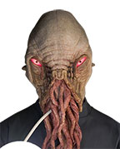

D. The Ood ____

E. Cybermen ____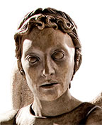

7. Who does the Doctor normally travel with?

The Doctor will normally be traveling with a Companion. This is typically been a female cast member who goes and shares his adventures with the Doctor.

8. In the start of Season 8 of the new Doctor Who how many Companions has the Doctor had?

A. 8

B. 34

C. 46

D. 54

9. Who does Captain Jack Harkness become and how?

He becomes the Face of Boe. He was named this on his home world when he was younger. When Rose Tyler in the form of Bad Wolf brings him back to life he was gifted with the inability to be killed. Since this eternal life is unnatural to him Jack still ages. Through this process he finally becomes the Face of Boe.

10. Who does the Doctor use to help defeat his foes?

A. Intellect

B. Sonic Screw Driver

C. Wit

D. Compassion

E. All of the above